**A**

**MINI PROJECT REPORT**

**ON**

**EAT-SHOP-LIVE@HYD**

SUBMITTED

BY

**D.SRIHARIKA**

**(1601-13-737-025)**

**&**

**Y.DEEPALI**

**(1601-13-737-003)**

FOR THE PARTIAL FULFILLMENT OF

(3/4)-B.E. INFORMATION TECHNOLOGY

UNDER THE GUIDANCE OF

**Mr. HANUMANTHA RAO**

**ASSISTANT PROFESSOR**



DEPARTMENT OF INFORMATION TECHNOLOGY

CHAITANYA BHARATHI INSTITUTE OF TECHNOLOGY

**(Affiliated to Osmania University; Accredited by NBA (AICTE), ISO Certified 9001:2000)**

**Website: www.cbit.ac.in, www.cbitworld.com**

HYDERABAD – 500 075

(i)



**CHAITANYA BHARATHI INSTITUTE OF**

**TECHNOLOGY**

**DEPARTMENT OF INFORMATION TECHNOLOGY**

**(Affiliated to OSMANIA UNIVERSITY)**

**GANDIPET, HYDERABAD-500 075**

**CERTIFICATE**

This is to certify that the project work entitled “**EAT-SHOP-LIVE@HYD**” submitted to **CHAITANYA BHARATHI INSTITUTE OF TECHNOLOGY**, in partial fulfillment of the requirements for the award of the completion of Third year 1st semester of B.E in information technology, during the academic year 2015, is a record of original work done by **D**.**SRIHARIKA (160113737025)** and **Y. DEEPALI (16013737003)** during the period of study in the Dept. of IT, CBIT, HYDERABAD, under our supervision and guidance.

**PROJECT GUIDE**  **HEAD OF THE DEPARTMENT**

**Mr.Hanumantha Rao Dr. K.Radhika**

**Assistant Prof. Dept of IT.** **Head of the department**

**Information Technology**

**C.B.I.T., HYDERABAD.**

(ii)

**ACKNOWLEDGEMENT**

I have taken efforts in this project. However, it would not have been possible without the kind support and help of many individuals and organizations. I would like to extend my sincere thanks to all of them.

I am highly indebted to **Dr. B.Chennakeshava Rao, The Principal**, **C.B.I.T.,** Hyderabad and **Dr. K.Radhika, Head of Department, Information Technology** for their guidance and constant supervision as well as for providing necessary information regarding the project & also for their support in completing the project.

I would like to express my gratitude to our guide **Mr.Hanumantha Rao, Assistant Professor, Dept of IT, C.B.I.T.,** for his kind co-operation and encouragement which help me in completion of this project.

My thanks and appreciations also go to my colleague in developing the project and people who have willingly helped me out with their abilities.

**D.SRIHARIKA**

**(1601-13-737-025)**

**&**

**Y.DEEPALI**

**(1601-13-737-003)**

(iii)

**DECLARATION**

We declare that the project report entitled “**EAT-SHOP-LIVE@HYD**” is being submitted by us in the Department of Information Technology, Chaitanya Bharathi Institute of Technology, Osmania University.

This is record of bonafide work carried out by us under the guidance and supervision of **Mr.Hanumantha Rao, Assistant Professor, Dept of IT, C.B.I.T.**

No part of the thesis copied from books/journals/internet and wherever the portion is taken, the same has been duly referred in the text. The reported are based on the project work doing entirely by us and not copied from any other source.

**D.SRIHARIKA**

**(1601-13-737-025)**

**&**

**Y.DEEPALI**

**(1601-13-737-003)**

(iv)

**ABSTRACT**

Developing HTML pages is the main objective of this project which can help a tourist to select a best place to stay, a good place to eat and a lively place to shop in Hyderabad as per his/her requirements.

This application is connected to a database which contains information regarding the various restaurants, hotels, shopping malls and sightseeing places in Hyderabad which can attract the tourists. It also holds information regarding the contact details, rating and address of the corresponding hotel, restaurant or the shopping mall. The user is displayed four icons namely hotels, restaurants, sightseeing and shopping. Depending on what the user selects, the corresponding data is retrieved from the database in the form of tables using MySQL and displays it on the screen. This helps the user to select a destination as per his/her interest. The website also takes in the feedback of the user and stores it in the database.

(v)

**TABLE OF CONTENTS**

Acknowledgement iii

Declaration iv

Abstract v

**Contents Page No.**

1. Introduction

1.1 Purpose 1

1.2 Scope 2

1.3 Overview 3

1.4 System Analysis 4

2. Software Requirements and Specifications 5

2.1 Software Requirements

2.2 Hardware requirements

3. Implementation

3.1 HTML 6

3.2 CSS 6

3.3 JSP 7

3.4 MySQL 7

4. Result 8

5. Conclusion and Future Scope 11

6.Bibliography 12

**LIST OF FIGURES**

**Figure No. Page No.**

4.1 Output Screen of Home Page 1 8

4.2 Output Screen of Home Page 2 8

4.3 Output Screen of Sightseeing page 9

4.4 Output Screen of Hotel Page. 9

4.5 Output Screen of Restaurant Page. 10

4.6 Output Screen of Shopping Page. 10

**INTRODUCTION**

**1.1** Purpose

EAT-SHOP-LIVE@HYD helps tourists who are new to Hyderabad to find the best and comfortable hotels to stay .It gives shopaholics details of the best shopping sites in Hyderabad. The tourists could easily find the address of the best sightseeing places in Hyderabad and the details of the wonderful restaurants to hog on .It serves the purpose of a travel guide for a person who is new to Hyderabad. One can explore the marvels of the city, travel around Hyderabad and explore its best and exquisite places to stay, eat and shop. The feedback of all these places is also provided with ratings which help you to choose the best hotels at your ease. At the end it takes the users feedback regarding the hotels, restaurants, shopping malls and sightseeing places in Hyderabad so that it could help us to change the rating as per the feedback provided, in future.

1

**1.2 Scope**

EAT-SHOP-LIVE@HYD can be used in exploring these four aspects in Hyderabad by tourists.

### Sightseeing

This website helps you to easily locate and explore new places of interest in Hyderabad. It helps the tourists to easily explore all the various places and enjoy the wonderful marvels and great grandeur of this Pearl City.

Hotels

This website helps you to find out the best and the affordable hotels in the city to stay while you explore the city. You can find the cheapest as well as the most luxurious hotels which suits your requirement. You can find hotels according to your preferences using this website.

### Shopping

Hyderabad is a shopper’s paradise .Explore wonderful shopping sites using this website. With the address provided it makes it easier for the tourists to explore the sites and enjoy shopping.

As Hyderabad is an exotic hub for shopaholics, with the address and the rating provided, it makes it easier for the tourists to shop.

### Restaurants

One cannot miss out the amazing yummy Hyderabad Biryani and irani chai .Hyderabad is best known for its Nawabi culunary skills .Using this website you could explore the best and ravishing cuisine of Hyderabad. So say yes to yummy food.

2

**1.3 Overview**

It helps the tourists who visit the city for the first time to easily explore all the places of interest .It helps them to easily identify the location of a hotel, restaurant or any mall they are looking for. It gives exact details of all the various cuisine type of restaurants for the tourists to hog on. It simplifies the life of a visitor by overall helping them to find a better place to sleep, eat and shop.

The website also self improvises itself by taking the feedback from the users. This helps us to change the rating of a particular hotel, restaurant, shopping mall or a sightseeing place respectively considering the users feedback.

**3**

**1.4 System Analysis**

We have carried out a comparative analysis on each of the pages in the website by requesting to search for hotels, restaurants, sightseeing and shopping. It worked perfectly well all the four times as it displayed the desirable results all the times.

**4**

**2. SOFTWARE REQUIREMENTS AND SPECIFICATIONS**

**2.1Software Requirements:**

* Operating System : Windows XP/7/8.1
* User Interface : HTML, CSS
* Client-side Scripting : JSP
* Programming Language: HTML, SQL, JSP

**2.2Minimum Hardware Requirements:**

* Processor : Pentium IV
* Hard Disk : 40GB
* RAM : 512MB

5

**3. IMPLEMENTATION**

**2.21 HTML**

Hyper Text Markup Language, commonly referred to as HTML, is the standard [markup language](https://en.wikipedia.org/wiki/Markup_language) used to create web pages .Web browsers can read HTML files and render them into visible or audible web pages. HTML describes the structure of a [web site](https://en.wikipedia.org/wiki/Website) semantically along with cues for presentation, making it a markup language, rather than a programming language.HTML elements form the building blocks of all websites. HTML allows images and objects to be embedded and can be used to create interactive forms. It provides a means to create structured documents by denoting structural semantics for text such as headings, paragraphs, lists, links, quotes and other items. The language is written in the form of HTML elements consisting of *tags* enclosed in angle brackets (like <html>). Browsers do not display the HTML tags and scripts, but use them to interpret the content of the page.

HTML can embed [scripts](https://en.wikipedia.org/wiki/Scripting_language) written in languages such as JavaScript which affect the behavior of HTML web pages. Web browsers can also refer to Cascading Style Sheets (CSS) to define the look and layout of text and other material. The World Wide Web Consortium (W3C), maintainer of both the HTML and the CSS standards, has encouraged the use of CSS over explicit presentational HTML since 1997

**2.22 CSS**

A cascading style sheet (CSS) is a Web page derived from multiple sources with a defined order of precedence where the definitions of any style element conflict. The Cascading Style Sheet, level 1 (CSS1) recommendation from the World Wide Web Consortium (W3C), which is implemented in the latest versions of the Netscape and Microsoft Web browsers, specifies the possible style sheets or statements that may determine how a given element is presented in a Web page. In general, the Web page creator's style sheet takes precedence, but it's recommended that browsers provide ways for the viewer to override the style attributes in some respects

6

**2.23** **JSP**

Java Server Pages (JSP) is a server-side programming technology that enables the creation of dynamic, platform-independent method for building Web-based applications. JSP have access to the entire family of Java APIs, including the JDBC API to access enterprise databases. It is a technology that helps software developers create dynamically generated web pages based on HTML, XML, or other document types. Released in 1999 by Sun Microsystems,[[1]](https://en.wikipedia.org/wiki/JavaServer_Pages#cite_note-1) JSP is similar to PHP and ASP, but it uses the Java programming language.

To deploy and run Java Server Pages, a compatible web server with a servlet container, such as Apache Tomcat or Jetty, is required.

**2.24 MySQL**

MySQL is a popular choice of database for use in web applications, and is a central component of the widely used LAMP open source web application software stack (and other "AMP" stacks). LAMP is an acronym for "Linux, Apache, MySQL, Perl /PHP/Python." Free-software-open source projects that require a full-featured database management system often use MySQL. Applications that use the MySQL database include: TYPO3, MODx, Joomla, WordPress, phpBB, MyBB, Drupal and other software. MySQL is also used in many high-profile, large-scale websites, Google (though not for searches), Facebook and Twitter.

On all platforms except Windows, MySQL ships with no GUI tools to administer MySQL databases or manage data contained within the databases. Users may use the included command line tools, or install MySQL Workbench via a separate download. Many third party GUI tools are also available.

7

**4.RESULTS**

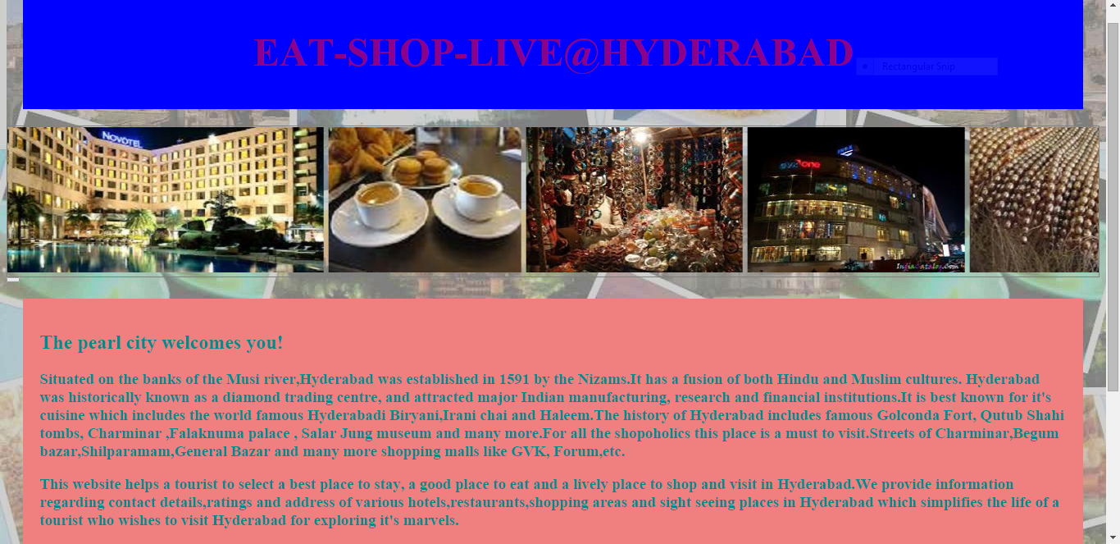

**4.1 OUTPUT SCREEN OF HOME PAGE 1**

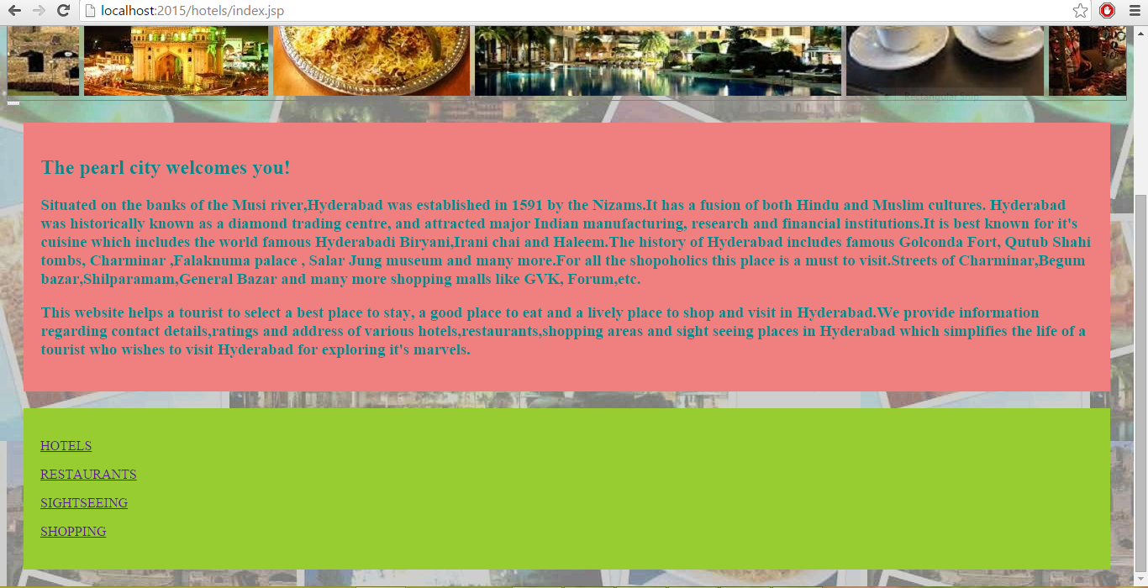

**4.2 OUTPUT SCREEN OF HOME PAGE 2**

8

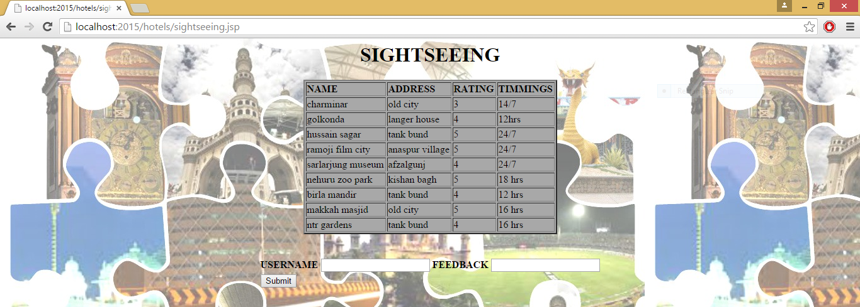

**4.3 OUTPUT SCREEN OF SIGHTSEEING**

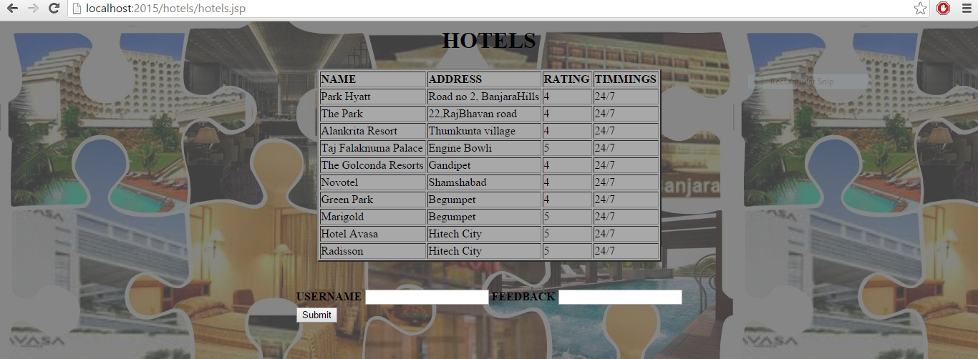

**4.4 OUTPUT SCREEN OF HOTELS**

9

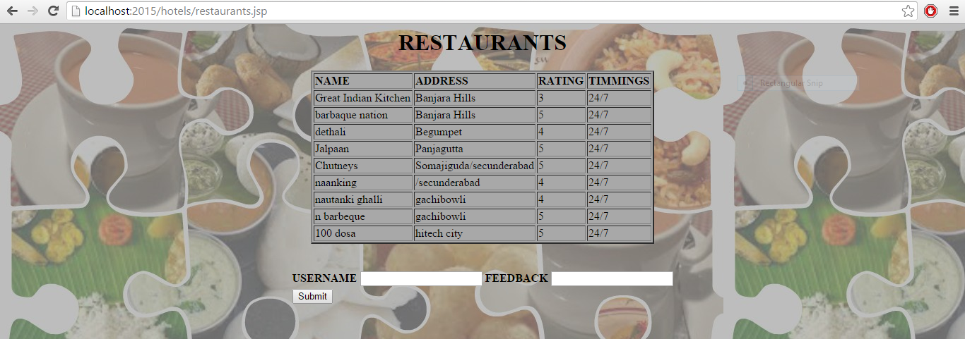

**4.5 OUTPUT SCREEN OF RESTAURANTS**

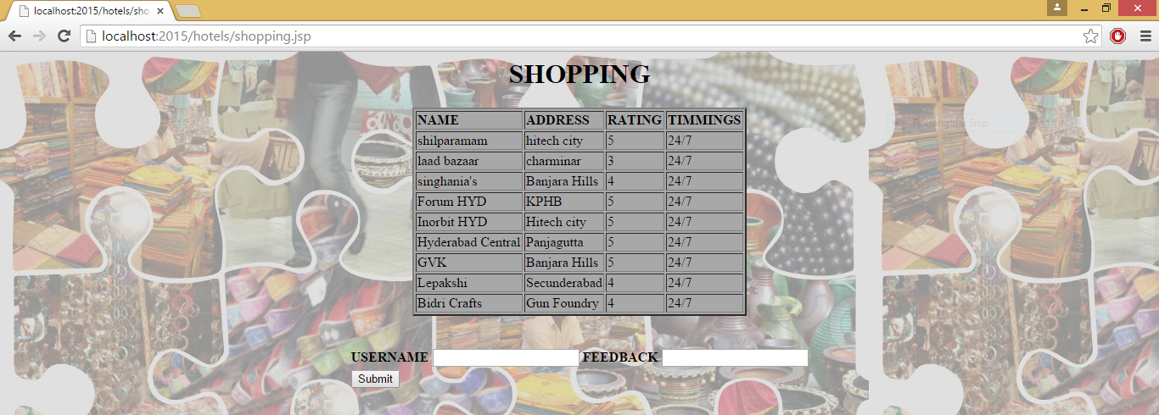

**4.6 OUTPUT SCREEN OF SHOPPING**

10

**5. CONCLUSION AND FUTURE SCOPE**

In this way this website helps a tourist to find out the best shopping sites, hotels, sightseeing sites and restaurants in Hyderabad. This application is connected to a database which contains information regarding the various restaurants, hotels and shopping malls in Hyderabad which can attract the tourists. It also holds information regarding the contact details, rating and address of the corresponding hotel, restaurant or the shopping mall. The user is displayed four icons namely hotels, restaurants, sightseeing and shopping. Depending on what the user selects, the corresponding data is retrieved from the database in the form of tables using MySQL and displays it on the screen. This helps the user to select a destination as per his/her interest.

There is a scope of increasing the database and the number of pages further. We can increases the tables and the table entries in future. The list of the number of hotels, restaurants, shopping sights and sightseeing sites can be increased further.

11

**6. BIBLIOGRAPHY**

1. HTML in W3schools.com

2. www.wikipedia.org

3. www.Tutorialspoint.com

4.www.stackoverflow.com

12